Python Basics: Assignment Submission
Name: Vaibhav Karkute
Subject: Python Scripting & File Handling

1. Grade Checker
Objective: Take a score as input and print the grade based on specific ranges using if-elif-else statements.

Code:
Python
# Grade Checker Program

score = int(input("Enter your score: "))

if score >= 90:
print("Grade: A")
elif score >= 80:
print("Grade: B")
elif score >= 70:
print("Grade: C")
elif score >= 60:
print("Grade: D")
else:
print("Grade: F")

Explanation:
- The program takes user input using input().
- It converts the input string to an integer using int().
- It uses if-elif-else conditional logic to check the score against the defined ranges and prints the corresponding grade.

Sample Output:
Plaintext
Enter your score: 85
Grade: B

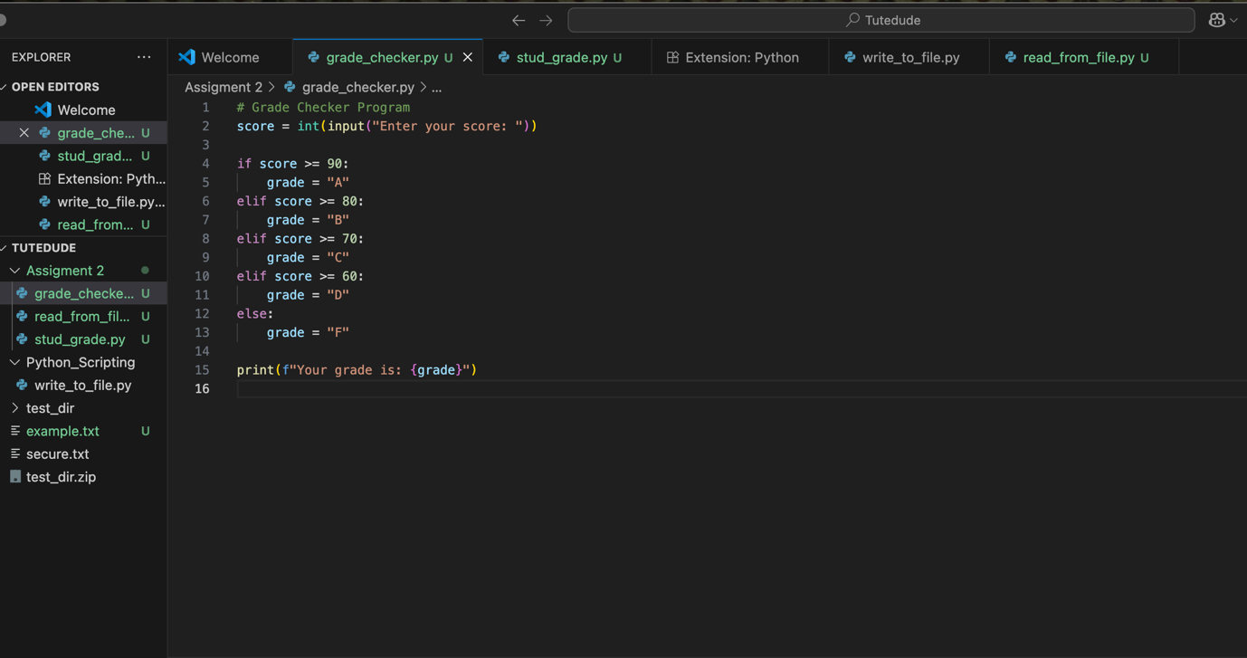

2. Student Grades Dictionary
Objective: Create a menu-driven program using a dictionary to store student names and grades, allowing the user to add, update, and print grades.

Code:
Python
# Student Grades Management

students = {}

while True:
print("\n1. Add Student")
print("2. Update Student Grade")
print("3. Display All Students")
print("4. Exit")

choice = input("Enter your choice: ")

if choice == '1':
name = input("Enter student name: ")
grade = input("Enter grade: ")
students[name] = grade
print(f"Added {name} with grade {grade}")

elif choice == '2':
name = input("Enter student name to update: ")
if name in students:
grade = input("Enter new grade: ")
students[name] = grade
print(f"Updated {name}'s grade to {grade}")
else:
print("Student not found.")

elif choice == '3':
print("\nStudent Grades:")
for name, grade in students.items():
print(f"{name}: {grade}")

elif choice == '4':
break

else:
print("Invalid choice!")

Explanation:
- Initializes an empty dictionary called students to store the data.
- Uses a while True loop to create a continuous menu-driven interface.
- Add: Assigns a new key-value pair via students[name] = grade.
- Update: Checks if the student exists using if name in students before updating.
- Display: Iterates through the dictionary using a for loop and the .items() method.

Sample Output:
Plaintext
1. Add Student
2. Update Grade
3. Print All Grades
4. Exit
Enter your choice: 1
Enter student name: vaibhav
Enter grade: B
Added vaibhav with grade B

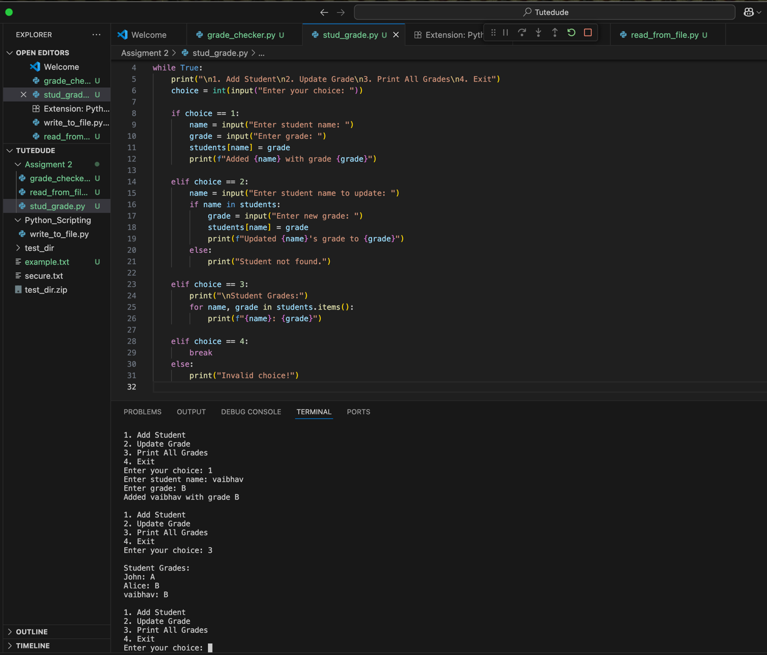

3. Write to a File
Objective: Write a program to create a text file and write content to it.

Code:
Python
# Write to File Program

file = open("example.txt", "w") # open in write mode
file.write("Hello, this is a test file.\nThis is the second line.")
file.close()

print("Data written to example.txt")

Explanation:
- open("example.txt", "w"): Opens (or creates) the file in write mode (w).
- file.write(): Inserts the specified string content into the text file. The \n character is used to create a new line.
- file.close(): Closes the file, ensuring the changes are saved properly and system resources are freed.

Sample Output:
Plaintext
Data written to example.txt
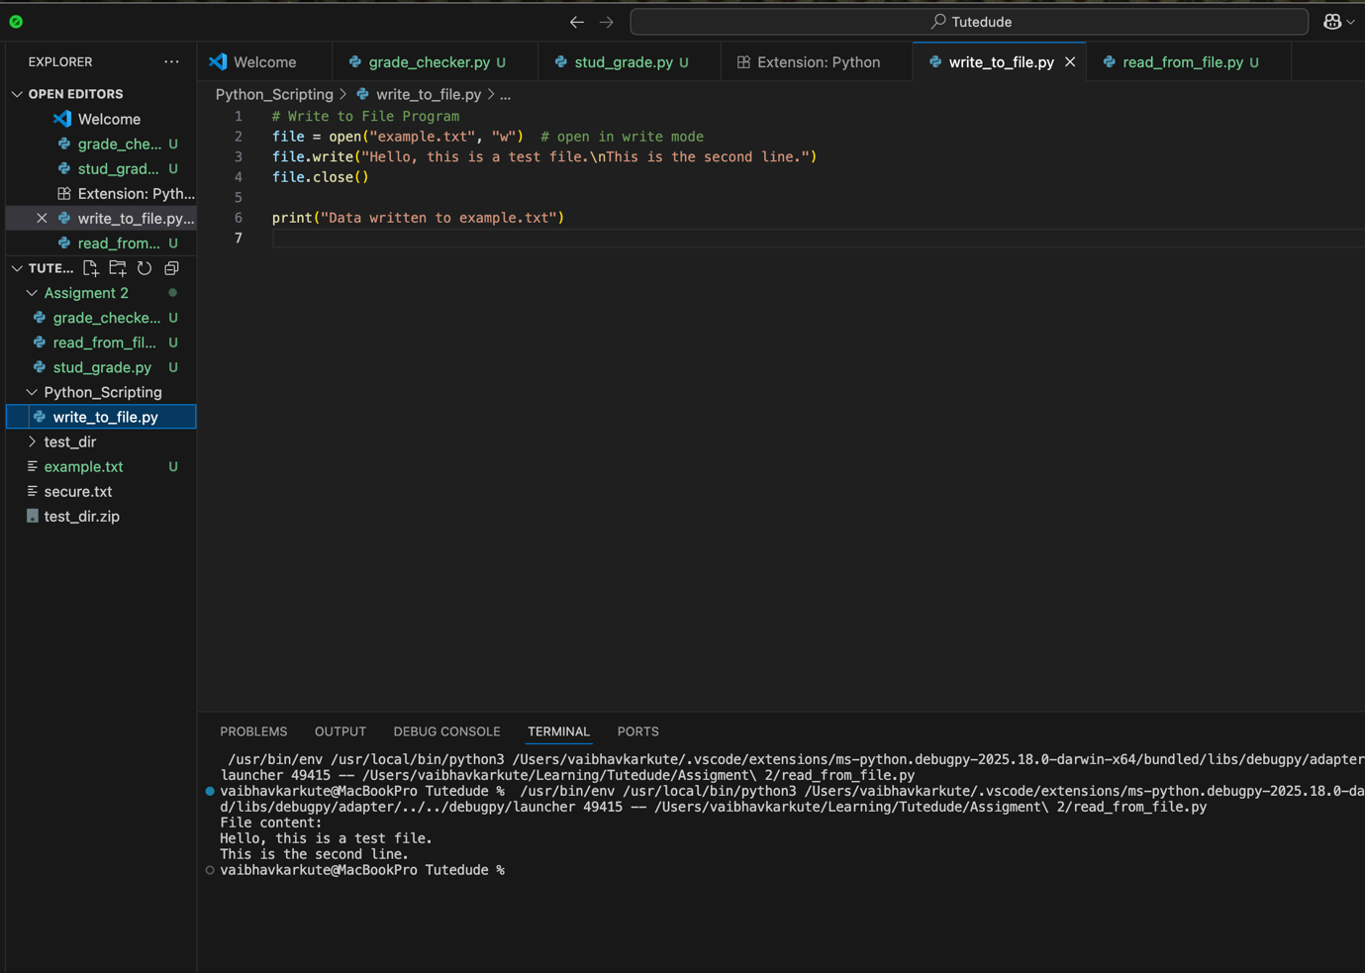

4. Read from a File
Objective: Read the contents of the previously created text file and display them in the console.

Code:
Python
# Read from File Program

file = open("example.txt", "r")
content = file.read()
print("File content:")
print(content)
file.close()

Explanation:
- open("example.txt", "r"): Opens the file in read mode (r).
- file.read(): Reads the entire content of the file and stores it in the content variable.
- The script then prints the stored string to the terminal.

Sample Output:
Plaintext
File content:
Hello, this is a test file.
This is the second line.

